**Raspberry Pi 5 3.6-inch Screen（MZP361WV1T）**

**User Guide**

**Product Features**

Display screen diagonal length: 3.61 inches

Physical resolution: 800×480

Refresh rate: 60Hz

Display mode: DPI666, 262K colors

Supports Raspberry Pi 5B/4B/3B+/3A+/3B/

Directly driven by Raspberry Pi's GPIO interface

**Hardware Connection**

The Raspberry Pi models 5B/4B/3B+/3B/ already have the 40-pin GPIO header soldered. Simply plug in the display directly.

**How to make the Screen Work**

1 Download the Raspberry Pi Imager software from the official website

2 Follow the official instructions to write the Raspberry Pi OS system to your memory card

3-1 If you are using the latest version of the Raspberry Pi OS (Bookworm), after the image writing is complete, copy the file mzp361wv1t-bookworm.txt to the root directory of the TF card. Then open the config.txt file in the root directory and add the following to the end of the file:

[all]

include mzp361wv1t-bookworm.txt

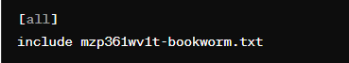

3-2 If you are using a version of the Raspberry Pi OS other than the latest (any version other than Bookworm), after the image writing is complete, copy the file mzp361wv1t-old.txt to the root directory of the TF card. Then open the config.txt file in the root directory and add the following to the end of the file: [all]

include mzp361wv1t-old.txt

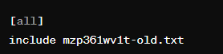

4 Save and safely remove the TF card.

5 Insert the completed TF card into the Raspberry Pi, power it on, wait for the system to boot

**GPIO detailed introduction:**

1. Within the 40-pin header of the Raspberry Pi, there are 28 GPIO pins, 2 +3.3V power pins, 2 +5V power pins, and 8 GND pins.

2. The display screen occupies 23 GPIO pins, which are unavailable for user usage:

·GPIO-0 //PCLK

·GPIO-1 //DE

·GPIO-2 //VS

·GPIO-3 //HS

--------------------

·GPIO-4 //B0

·GPIO-5 //B1

·GPIO-6 //B2

·GPIO-7 //B3

·GPIO-8 //B4

·GPIO-9 //B5

-------------------

·GPIO-12 //G0

·GPIO-13 //G1

·GPIO-14 //G2

·GPIO-15 //G3

·GPIO-16 //G4

·GPIO-17 //G5

-------------------

·GPIO-18 // Backlight Control

-------------------

·GPIO-20 //R0

·GPIO-21 //R1

·GPIO-22 //R2

·GPIO-23 //R3

·GPIO-24 //R4

·GPIO-25 //R5

1. The unused GPIOs on the display screen, which users can freely utilize, are as follows:

·GPIO-10

·GPIO-11

·GPIO-19

·GPIO-26

·GPIO-27

**How to rotate the screen:**

**Raspberry Pi OS (bookworm)**

Open "Screen Configuration" , Follow the instructions in the image below to proceed

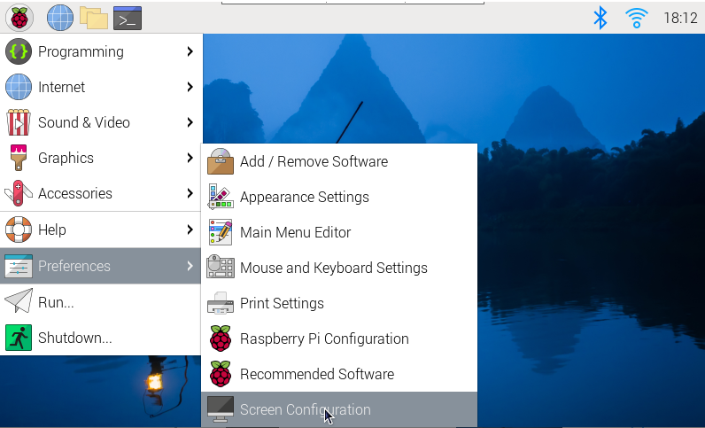

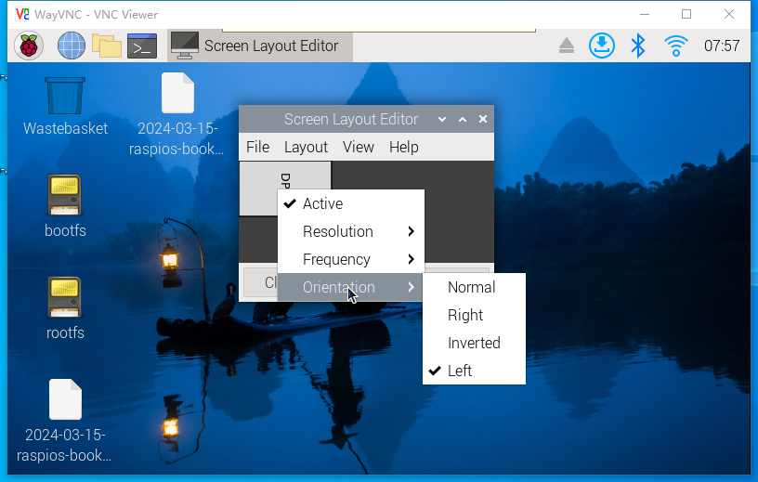

**Raspberry Pi OS other than the latest (any version other than Bookworm)**

Modify the content in file mzp361wv1t-old.txt：

display_rotate=1 #1：90；2: 180； 3: 270

**Backlight Control:**

**Raspberry Pi OS (bookworm)**

Enter the following command in the console.

Turn off backlight:

sudo sh -c 'echo "0" > /sys/class/backlight/backlight/brightness'

Turn on backlight:

sudo sh -c 'echo "1" > /sys/class/backlight/backlight/brightness'

**Raspberry Pi OS other than the latest (any version other than Bookworm)**

Enter the following command in the console.

To turn the backlight off:

sudo raspi-gpio set 18 op dl

To turn it back on:

sudo raspi-gpio set 18 op dh